**Angular Exercise:**

**Question:**

3.**Interpolation – Display favorite movie**   
   
Modify angular-learning application to display your favorite movie name.   
   
Create a property named favoriteMovie in app.component.ts   
   
Display the favorite movie in the below format:   
   
**Favorite Movie:** Lord of the Rings   
   
**Code:**

App.component.ts:

import { Component } from '@angular/core';

@Component({

  selector: 'app-root',

  templateUrl: './app.component.html',

  styleUrls: ['./app.component.css']

})

export class AppComponent {

  favoriteMovie: string='Lord of the Rings';

}

App.component.html:

<h3>Favorite Movie: {{favoriteMovie}}.</h3>

**Output:**

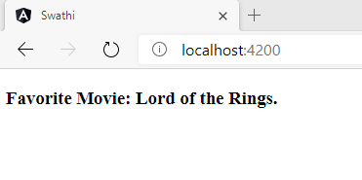

**Question:**

4.**Interpolation – Display Employee details**   
   
Modify angular-learning application to display employee’s id, name and salary.   
   
Use Employee, Department and Skill interfaces created earlier.   
   
Sample screen layout

**Code:**

Interfaces:

Employee.ts:

export interface Employee{

    id:number;

    name:string;

    salary:number;

}

Skill.ts:

export interface Skill{

    skill_id:number;

    skill_name:string;

}

Department.ts:

export interface Department{

    department_id:number;

    department_name;number;

}

Employee.component.ts:

import { Component, OnInit } from '@angular/core';

import { Employee } from '../Employee';

@Component({

  selector: 'app-employee',

  templateUrl: './employee.component.html',

  styleUrls: ['./employee.component.css']

})

export class EmployeeComponent implements OnInit {

  emp:Employee={

    id:25,

    name:"Swathi",

    salary:25000,

  };

  constructor() { }

  ngOnInit(): void {

  }

}

Employee.component.html:

<div>

<h1> Employee details</h1>

<div class="well hoverwell thumbnail">

    <h2>{{emp.id}}</h2>

    <h2>{{emp.name}}</h2>

    <div>Salary: {{emp.salary}}</div>

</div>

</div>

App.component.html:

<app-employee></app-employee>

**Output:**

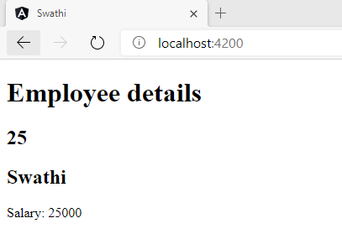

**Question:**

5.**Interpolation – Display employee permanent details using ngIf**   
   
Include employee permanent details using ngIf directive.   
   
Sample Layout

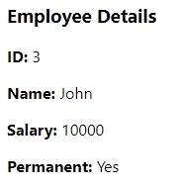

**Code:**

Employee.component.ts:

import { Component, OnInit } from '@angular/core';

import { Employee } from '../Employee';

@Component({

  selector: 'app-employee',

  templateUrl: './employee.component.html',

  styleUrls: ['./employee.component.css']

})

export class EmployeeComponent implements OnInit {

  emp:Employee={

    id:25,

    name:"Swathi",

    salary:25000,

  };

  show:boolean=true;

  constructor() { }

  ngOnInit(): void {

  }

}

Employee.component.html:

<div>

<h1> Employee details</h1>

<div class="well hoverwell thumbnail">

    <h2>{{emp.id}}</h2>

    <h2>{{emp.name}}</h2>

    <div>Salary: {{emp.salary}}</div>

    <div *ngIf="show">Permanent: Yes </div>

</div>

</div>

**Output:**

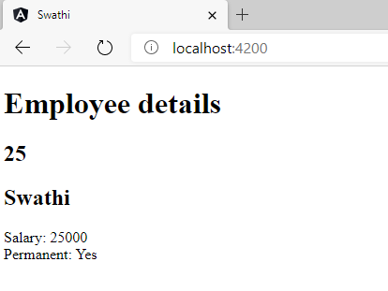

**Question:**

6.**Interpolation – Display employee department details**   
   
Interpolation – Display employee department details   
   
Sample Layout

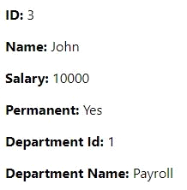

**Code:**

Employee.component.ts:

import { Component, OnInit } from '@angular/core';

import { Employee } from '../Employee';

@Component({

  selector: 'app-employee',

  templateUrl: './employee.component.html',

  styleUrls: ['./employee.component.css']

})

export class EmployeeComponent implements OnInit {

  emp:Employee={

    id:25,

    name:"Swathi",

    salary:25000,

    depart:

      {department_id:100,department_name:"Payroll"},

  };

  show:boolean=true;

  constructor() { }

  ngOnInit(): void {

  }

}

Employee.component.html:

<div>

<h1> Employee details</h1>

<div class="well hoverwell thumbnail">

    <h2>Employee Id: {{emp.id}}</h2>

    <h2>Employee Name: {{emp.name}}</h2>

    <h2>Salary: {{emp.salary}}</h2>

    <h2 *ngIf="show">Permanent: Yes </h2>

    <h2>Department Id: {{emp.depart.department_id}}</h2>

    <h2>Department Name: {{emp.depart.department_name}}</h2>

</div>

</div>

Employee.ts:

import { Department } from './Department';

export interface Employee{

    id:number;

    name:string;

    salary:number;

    depart:Department;

}

**Output:**

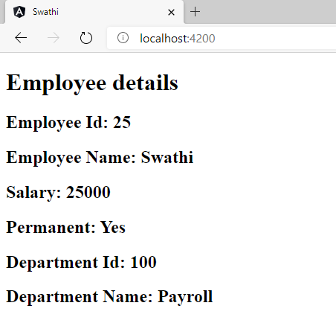

**Question:**

7.**Interpolation – Display employee skill details using ngFor**   
   
Include employee skill details using ngFor directive.   
   
Sample Layout

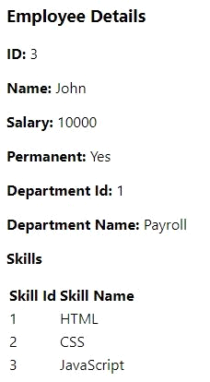

**Code:**

Employee.component.ts:

import { Component, OnInit } from '@angular/core';

import { Employee } from '../Employee';

import { Skill } from '../Skill';

@Component({

  selector: 'app-employee',

  templateUrl: './employee.component.html',

  styleUrls: ['./employee.component.css']

})

export class EmployeeComponent implements OnInit {

  emp:Employee={

    id:25,

    name:"Swathi",

    salary:25000,

    depart:

      {department_id:100,department_name:"Payroll"},

    skill:{skill_id:23,skill_name:"css"},

      };

  show:boolean=true;

  constructor() { }

  ngOnInit(): void {

  }

  empl:Employee[]=[

    {id:10,name:"ram",salary:25000,depart:

    {department_id:1,department_name:"java"},

       skill:{skill_id:1,skill_name:"HTML"}},

       {id:11,name:"ramu",salary:29000,depart:

       {department_id:2,department_name:"c++"},

       skill:{skill_id:2,skill_name:"CSS"}},

       {id:12,name:"ramya",salary:52000,depart:

       {department_id:3,department_name:"JS"},

       skill:{skill_id:2,skill_name:"JavaScript"}},

  ]

}

Employee.component.html:

<div>

<h1> Employee details</h1>

<div class="well hoverwell thumbnail">

    <h2>Employee Id: {{emp.id}}</h2>

    <h2>Employee Name: {{emp.name}}</h2>

    <h2>Salary: {{emp.salary}}</h2>

    <h2 *ngIf="show">Permanent: Yes </h2>

    <h2>Department Id: {{emp.depart.department_id}}</h2>

    <h2>Department Name: {{emp.depart.department_name}}</h2>

    <h2>Skills</h2>

    <table >

        <tr>

            <th>Skill Id</th>

            <th>Skill Name</th>

     </tr>

     <tr *ngFor="let emp of empl">

        <td>{{emp.skill.skill_id}}</td>

        <td>{{emp.skill.skill_name}}</td>

    </tr>

        </table>

</div>

</div>

Employee.ts:

import { Department } from './Department';

import { Skill } from './Skill';

export interface Employee{

    id:number;

    name:string;

    salary:number;

    depart:Department;

    skill:Skill;

}

**Output:**

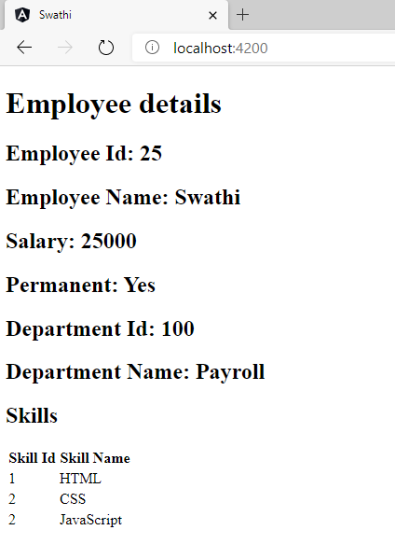

**Question:**

8.**Interpolation - Display employee details with date of birth**   
   
Inlude dateOfBirth property of type Date in employee.ts.   
   
Set dateOfBirth value in component.ts using new Date('12/31/2000') option.   
   
Include Date of Birth details in html.   
   
Sample Layout

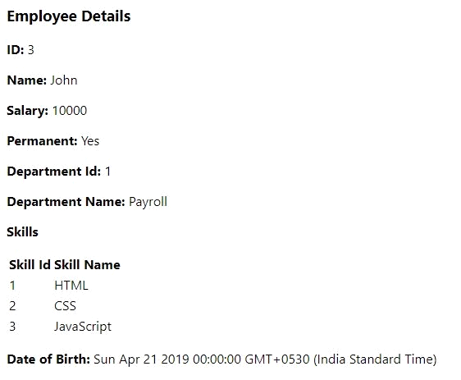

**Code:**

Employee.component.ts:

import { Component, OnInit } from '@angular/core';

import { Employee } from '../Employee';

import { Skill } from '../Skill';

@Component({

  selector: 'app-employee',

  templateUrl: './employee.component.html',

  styleUrls: ['./employee.component.css']

})

export class EmployeeComponent implements OnInit {

  emp:Employee={

    id:25,

    name:"Swathi",

    salary:25000,

    depart:

      {department_id:100,department_name:"Payroll"},

    skill:{skill_id:23,skill_name:"css"},

    dateOfBirth:new Date("Sun Apr 21 2019 00:00:00 GMT+0530(India Standard Time"),

      };

  show:boolean=true;

  constructor() { }

  ngOnInit(): void {

  }

  empl:Employee[]=[

    {id:10,name:"ram",salary:25000,depart:

    {department_id:1,department_name:"java"},

       skill:{skill_id:1,skill_name:"HTML"},dateOfBirth:new Date("Sun Apr 21 2019 00:00:00 GMT+0530(India Standard Time")},

       {id:11,name:"ramu",salary:29000,depart:

       {department_id:2,department_name:"c++"},

       skill:{skill_id:2,skill_name:"CSS"},dateOfBirth:new Date("Sun Apr 21 2019 00:00:00 GMT+0530(India Standard Time")},

       {id:12,name:"ramya",salary:52000,depart:

       {department_id:3,department_name:"JS"},

       skill:{skill_id:3,skill_name:"JavaScript"},dateOfBirth:new Date("Sun Apr 21 2019 00:00:00 GMT+0530(India Standard Time")},

  ]

}

Employee.component.html;

<div>

<h1> Employee details</h1>

<div class="well hoverwell thumbnail">

    <h2>Employee Id: {{emp.id}}</h2>

    <h2>Employee Name: {{emp.name}}</h2>

    <h2>Salary: {{emp.salary}}</h2>

    <h2 *ngIf="show">Permanent: Yes </h2>

    <h2>Department Id: {{emp.depart.department_id}}</h2>

    <h2>Department Name: {{emp.depart.department_name}}</h2>

    <h2>Skills</h2>

    <table >

        <tr>

            <th>Skill Id</th>

            <th>Skill Name</th>

     </tr>

     <tr *ngFor="let emp of empl">

        <td>{{emp.skill.skill_id}}</td>

        <td>{{emp.skill.skill_name}}</td>

    </tr>

        </table>

     <h2>Date Of Birth: {{emp.dateOfBirth}}</h2>

</div>

</div>

Employee.ts;

import { Department } from './Department';

import { Skill } from './Skill';

export interface Employee{

    id:number;

    name:string;

    salary:number;

    depart:Department;

    skill:Skill;

    dateOfBirth:Date;

}

**Output:**

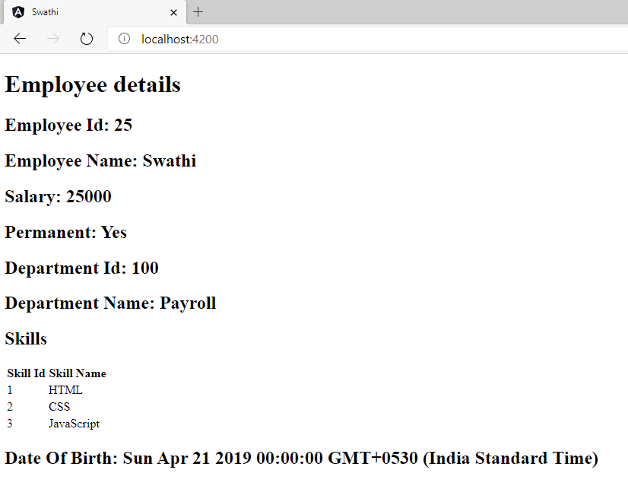

**Code:**

Employee.component.html:

<div>

<h1> Employee details</h1>

<div class="well hoverwell thumbnail">

    <h2>Employee Id: {{emp.id}}</h2>

    <h2>Employee Name: {{emp.name}}</h2>

    <h2>Salary: {{emp.salary | currency:"INR"}}</h2>

    <h2 *ngIf="show">Permanent: Yes </h2>

    <h2>Department Id: {{emp.depart.department_id}}</h2>

    <h2>Department Name: {{emp.depart.department_name}}</h2>

    <h2>Skills</h2>

    <table >

        <tr>

            <th>Skill Id</th>

            <th>Skill Name</th>

     </tr>

     <tr *ngFor="let emp of empl">

        <td>{{emp.skill.skill_id}}</td>

        <td>{{emp.skill.skill_name}}</td>

    </tr>

        </table>

     <h2>Date Of Birth: {{emp.dateOfBirth | date:'longDate'}}</h2>

</div>

</div>

**Output:**

